******** Docker with Jenkins *************

create instance on AWS with ubuntu 20.01 OS

once the instance started connect it with the help of MobaXterm

-------------------------------------

Step 1:

***************Docker installation on Ubuntu OS *********************

> sudo apt-get update

> sudo apt-get install ca-certificates curl gnupg lsb-release

>curl -fsSL https://download.docker.com/linux/ubuntu/gpg | sudo gpg --dearmor -o /usr/share/keyrings/docker-archive-keyring.gpg

> echo "deb [arch=$(dpkg --print-architecture) signed-by=/usr/share/keyrings/docker-archive-keyring.gpg] https://download.docker.com/linux/ubuntu $(lsb_release -cs) stable" | sudo tee /etc/apt/sources.list.d/docker.list /dev/null

***** Install Docker Engine ***************

> sudo apt-get update

> sudo apt-get install docker-ce docker-ce-cli containerd.io

********* let's check docker installed or not ****************

> sudo docker -v or sudo docker --version

> sudo docker info

Let's create a docker image of our code

|  |  |
| --- | --- |
|  |  |
|  | > git clone https://github.com/sonam-niit/docker_master.git |
|  | > cd docker_master |
|  | > ls (check the no of files and folder in docker_master folder) |
|  |  |
|  | > sudo docker build -t myimage . (. is mendatory) |
|  |  |
|  | > sudo docker images (to check the available images) |
|  |  |
|  | > sudo docker run -d --name mycontainer -p 80:80 myimage |
|  | (run image on mycontainer) |
|  |  |
|  | >sudo docker container ps -a (check available containers) |
|  |  |
|  | >curl localhost:80 |
|  | (check the running file on 80 port) |
|  |  |
|  | the same you can see on your publicip:80 |

********** Deploy image on docker swarm ************

docker swarm : managin multiple containers running on diffrent hosts

------------------------------------------------------------------------

where we will initialize swarm that node become leader node

and other nodes can join to this node and you can use them as worker node

---------------------------------------------------------------------------

to access : sudo chmod 666 /var/run/docker.sock

step 1: initialize docker swarm

> docker swarm init

> docker node ls

(managerial status of your node is Leader)

step 2: create service in docker swarm

>docker service create -p 8081:8081 --name webserve myimage

>docker service ls

you can see the running service

(published on 8081 but target is 80)

>curl localhost:80

******** Scale a docker container on a dockere swarm ***********

>docker service ls

>docker service ps webserve

>docker service scale webserve=3

>docker service ls

>docker service ps webserve

Step 2: Install JDK

-----------------------------

>sudo apt-get update

>sudo apt install default-jdk -y

Step 3: install maven

-----------------------------

>sudo apt install maven -y

Step 4: install jenkins

------------------------------------

> curl -fsSL https://pkg.jenkins.io/debian-stable/jenkins.io.key | sudo tee /usr/share/keyrings/jenkins-keyring.asc > /dev/null

> echo deb [signed-by=/usr/share/keyrings/jenkins-keyring.asc] https://pkg.jenkins.io/debian-stable binary/ | sudo tee /etc/apt/sources.list.d/jenkins.list > /dev/null

> sudo apt-get update

> sudo apt-get install jenkins

*****start jenkins service*****

> sudo service jenkins start

*****to check jenkins service*****

> sudo service jenkins status

> ctrl + c

>sudo cat /var/lib/jenkins/secrets/initialAdminPassword

(copy the initialAdminPassword)

open publicIp:8080

enter password and install suggested Plugins

---------------------------------------------------------------------------------------------

set up login

add username and password (remember) , add full name and email

continue and you will be redirected to jenkins Dashboard

------------------------------------------------------------------------------------------

Step 5: install Docker plugin in jenkins

manage jenkins> manage plugins> available >docker > install without retstart

Step 6: configure Docker cloud

manageJenkins> manage nodes and clouds> check lefthand side (configure cloud)>

>click on add a new cloud> select docker > click on cloud details>Enter Host URI: unix:///var/run/docker.sock

test connection if getting error of access denied

go to you instance console and execute below command

>sudo chmod 777 /var/run/docker.sock

>refresh jenkins

and test it again

----------------------------------------------------------------------------

step 7:

click on new Item

jenkinsdockerpipeline> freestyle project>ok

click on configure

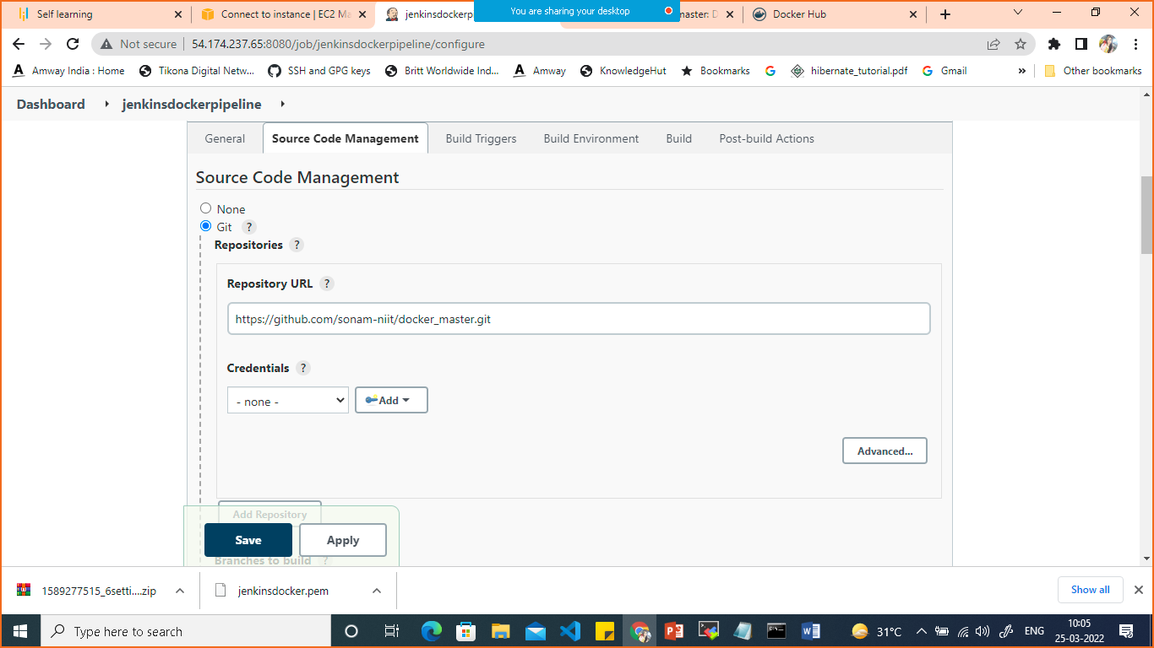

In Source Code management add git repo URL

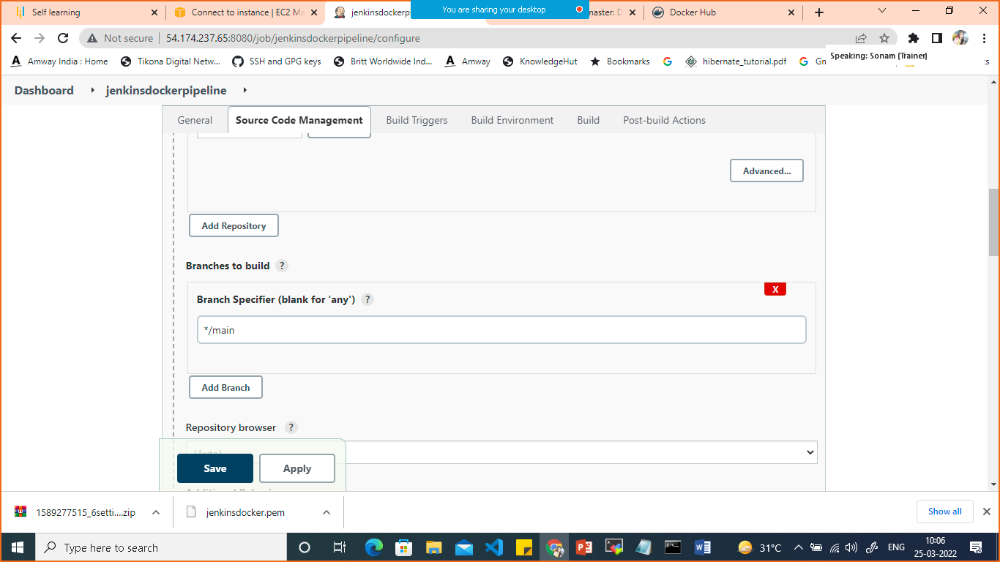

Give the branch name as main

Click on Poll HCM

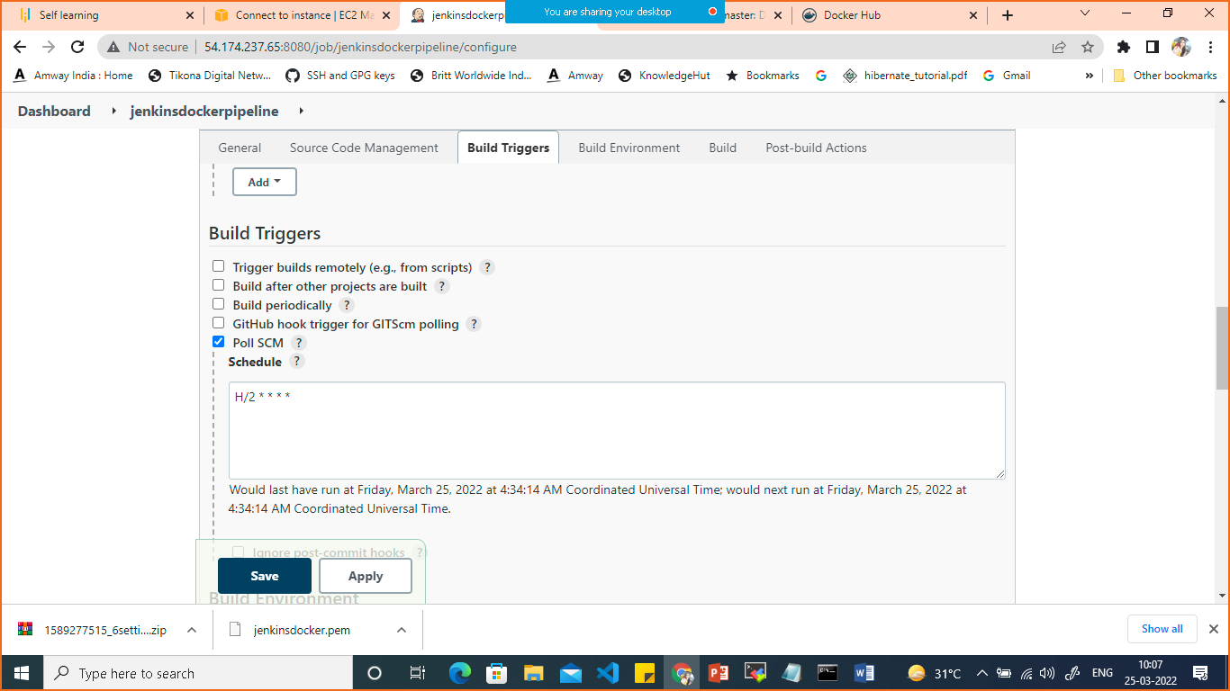

Scroll down in build select add and publish docker

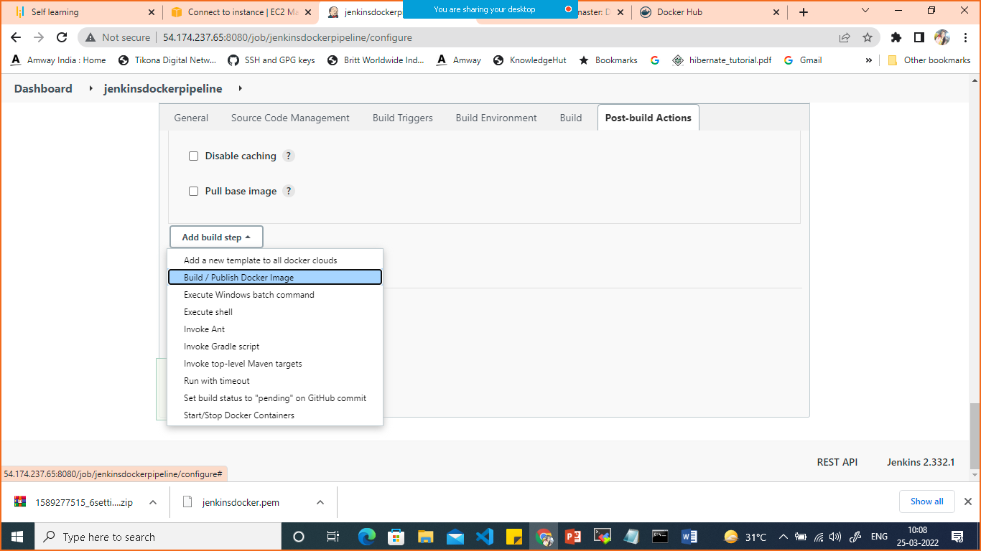

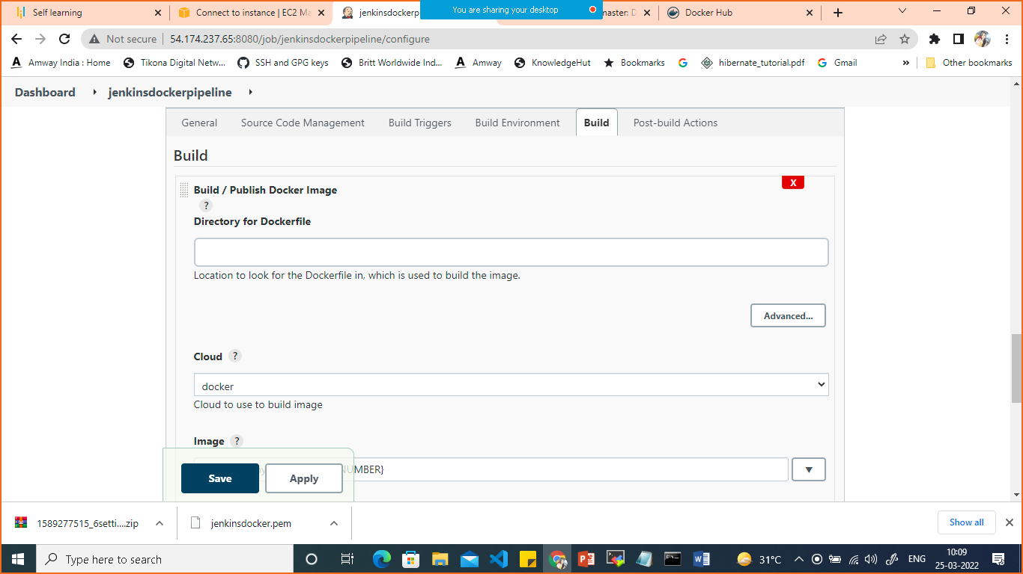

In cloud select docker

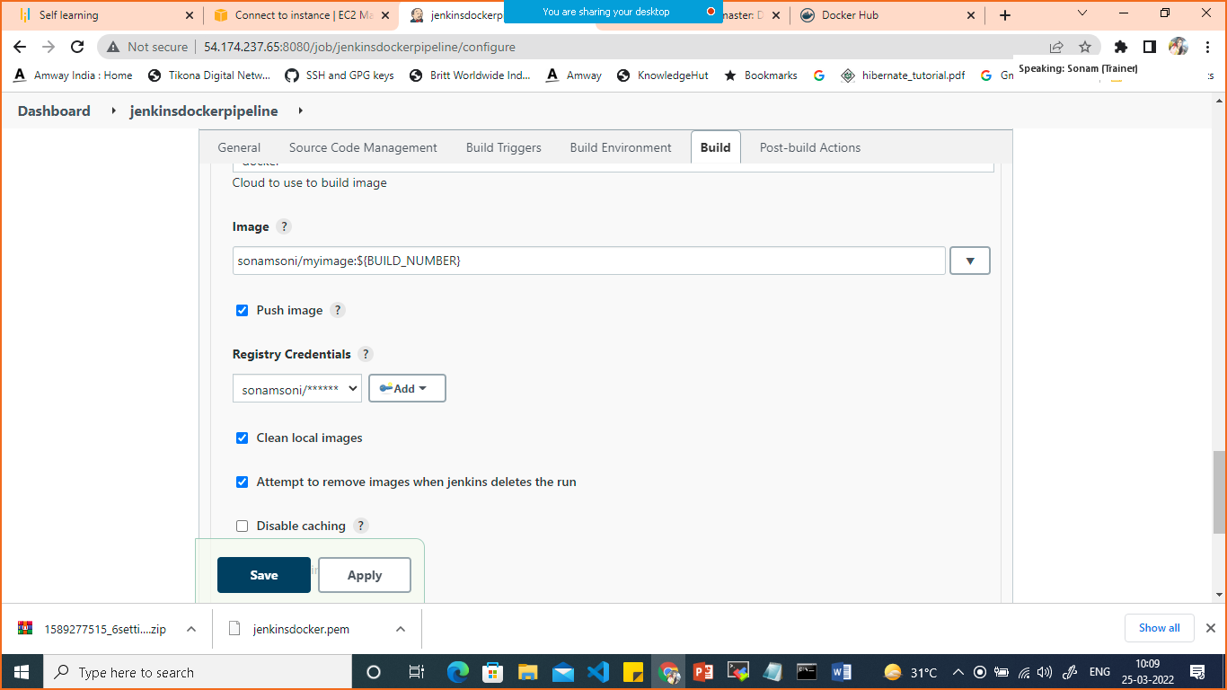

For adding docker credentials

Click on add credentials >Jenkins

Select Kind> username and password

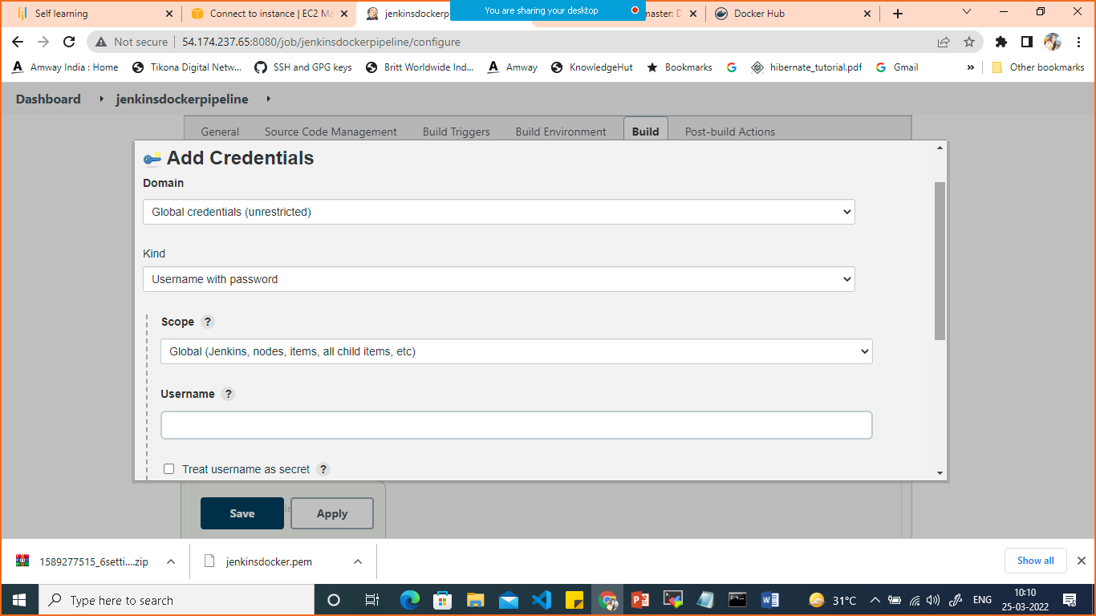

Give dockerhub username and password

Then select your credentials in registry credentials which you have added.

Save.

Click on buid now

It will build the image and push it on dockerhub

If you make any changes in your github automatically it will build a new image.